Look for an image on the internet, or use the image below, and write several sentences in which you describe the image using:

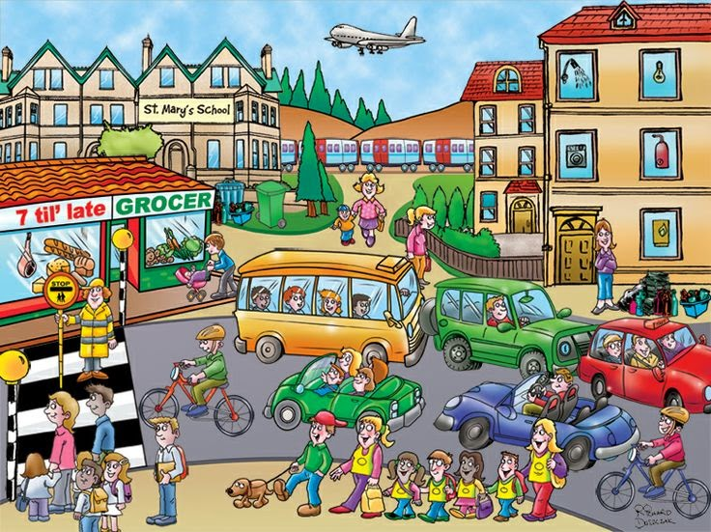
- Adjectives
  - The green car is smaller than the yellow bus.
- Adverbs
  - The man with the red bicycle cycles fast.
  - Her hair dances beautifully in the wind.
- Comparatives
- Possessive pronouns
  - His dog is the largest dog in the entire neighbourhood.
- To be able to
  - He is able to fly a plane.
- To be allowed to
  - They are allowed to cross the street.
- The tenses (present simple, present continuous, present perfect, past simple, past continuous, present passive, future)
  - They wait in front of the pedestrian crossing.
  - She is walking with a baby carriage.
  - I have never flown in a plane.
  - He was cycling when he was ordered to stop.
  - The dog is walked every morning by Aaleyah.
  - When I am older, I will go to St. Mary’s School for Extraordinary Children.
- Much / many / little / few
  - There are many people.
  - They make much noise.
  - There was little time for shopping.
  - Few people leaver their hometown.
- Modal verbs
  - He could have missed the bus.
  - He can’t drive.
  - Children have to wear a uniform at school.
  - You should stop in front of a pedestrian crossing.
  - You may not use the bicycle today.
  - Fatim will always be late.
  - When I still lived there, we would often go to the grocer.

